**Topic:** Hippocrates of Chios

**Notes on Topic:** Hippocrates, born on the island of Chios in the 5th century BC, note Hippocrates of Cos is the greek father of medicine, not our Hippocrates  
Aristotle wrote that Hippocrates while being great in the field of mathematics and geometry, was otherwise “to have been stupid and lacking in sense” playing into the stereotype that mathematicians were overwhelmed by everyday life  
Legend: Hippocrates’ fortune was taken by pirates who took him for an easy mark, so he travelled to Athens to regain his fortune through teaching -- “thus becoming him one of the few individuals ever to enter the teaching profession for its financial rewards”  
  
His contributions: one being his compositions of the first Elements, the first exposition developing the theorems of geometry precisely and logically from a few given axioms or postulates. This Elements was lost in history, and vastly eclipsed by Euclid’s Elements over a century later. There is reason to believe that Euclid borrowed from his great predecessor, thus much is owed to the great Hippocrates.  
The other great contribution, The Quadrature of the Lune, has not been lost. Hippocrates own work is not present, in fact what we really have is Simplicius’ (530 AD) summary of Eudemus’ account (335BC) of Hippocrates work.   
  
Quadrature: The Greeks were enthralled by the symmetries, the visual beauty and the subtle logical structure of geometry. How the simple and elementary could serve as foundation for the complex and intricate.  
Another example of the simple serving the complex is the classic constructions of one and two dimensional shapes using only an unmarked straightedge and a compass.   
Quadrature: the quadrature of a plane figure is the construction using only a compass and straightedge of a square having equal area to that of the original figure. If the quadrature of the plane figure is accomplished, the original figure is quadrable   
The appeal of the quadrature is taking something asymmetric and imperfect and replacing it with a perfect, symmetric square. The irrational by the rational.  
  
**In Class Activity: all of these quadratures ultimately lead up to the lune**

**Quadrature of the rectangle:**

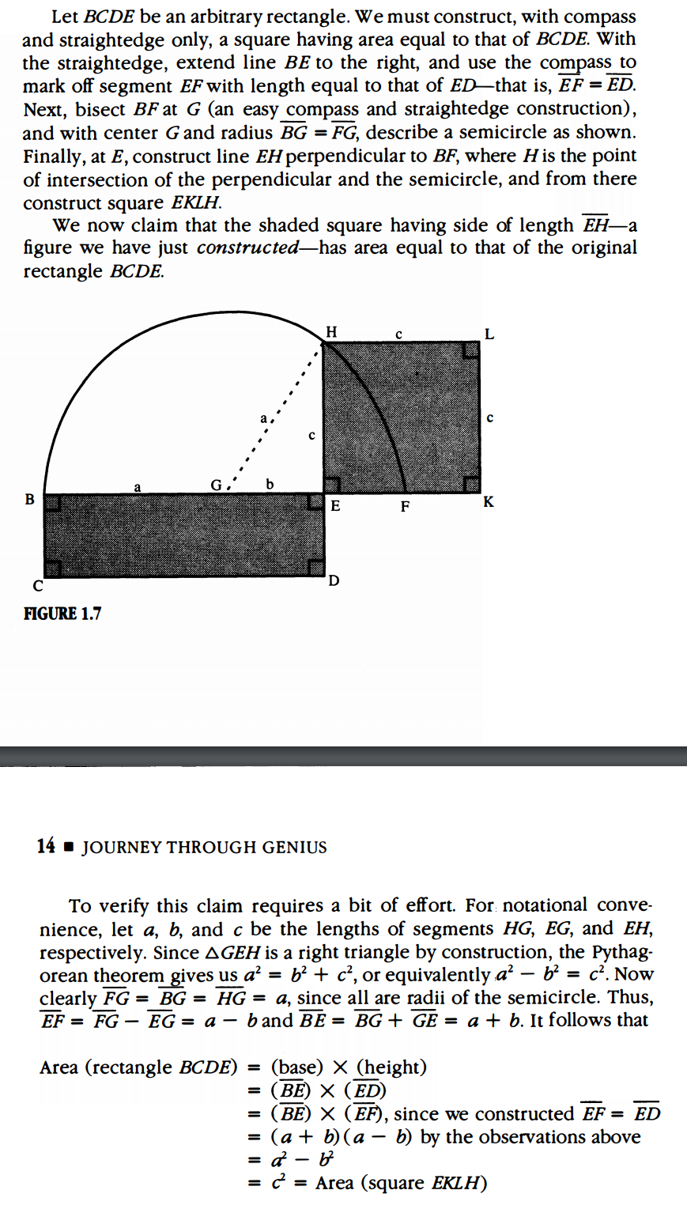

**Quadrature of a triangle:**

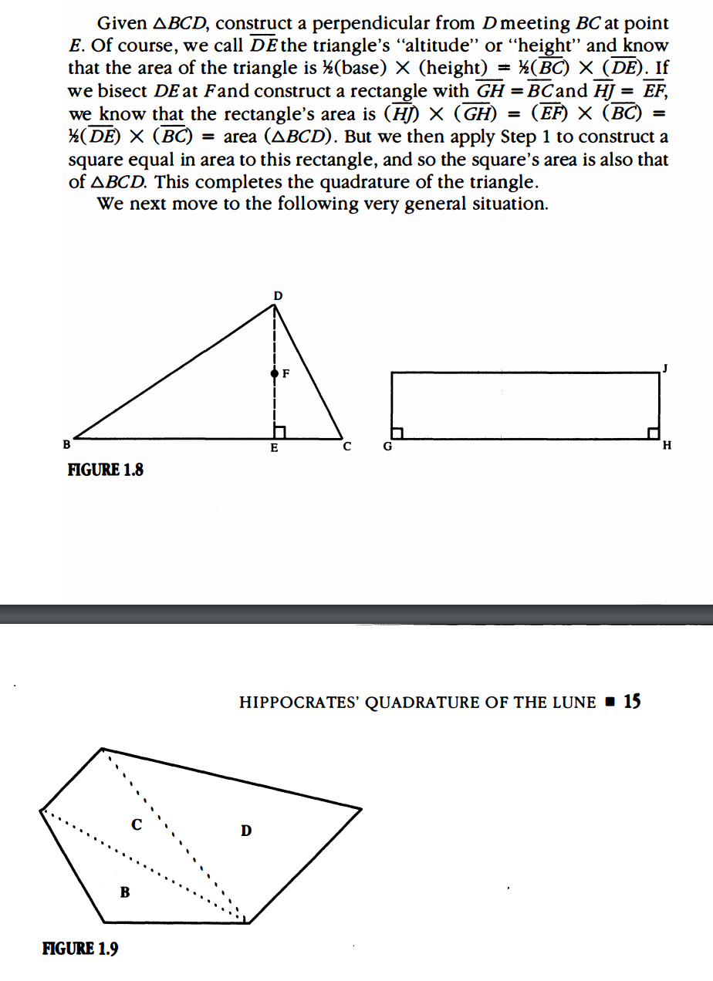

**Quadrature of a polygon:**

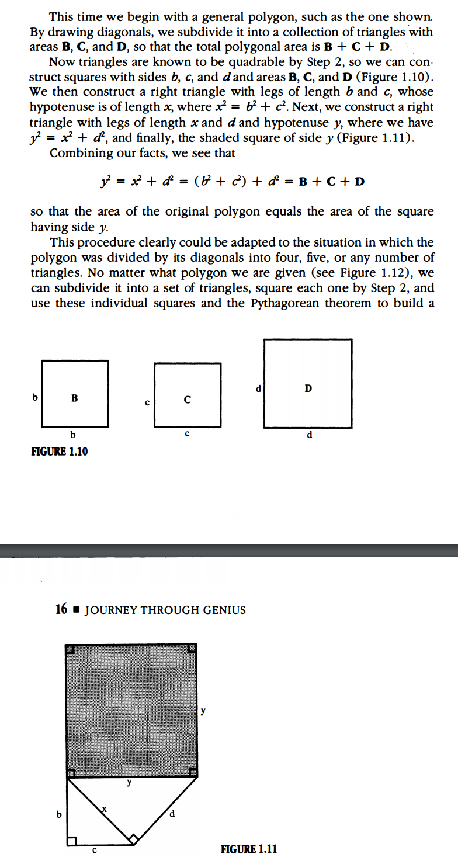

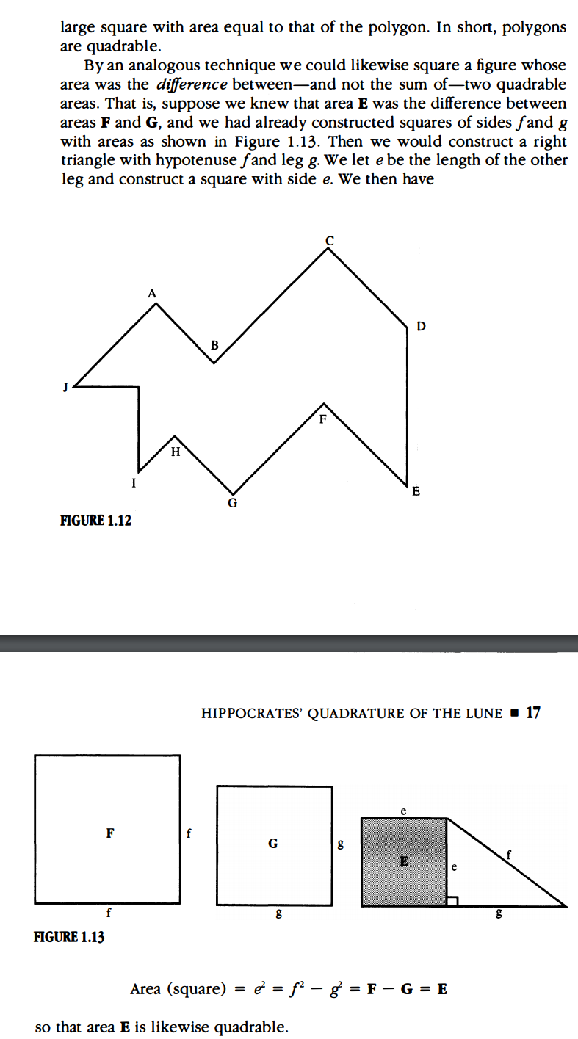

**Additional Suggested Reading**: Epilogue, Chapter 1 - on transcendental numbers, it will be part of the homework assignment

**Assignment:** Homework 1, Problem 5,